1. Joshua Freund
2. 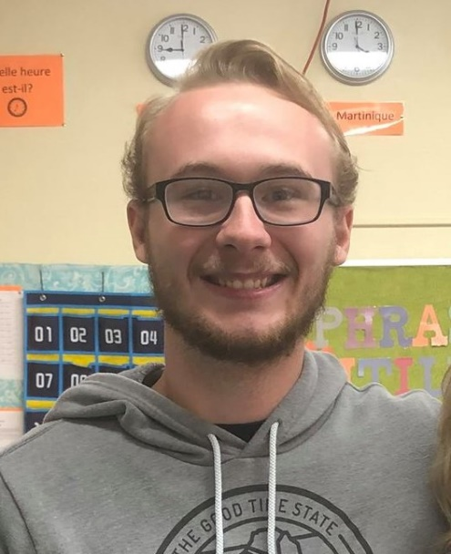
3. Computer Engineering – Senior Year
4. Founding Father of a Fraternity on Campus, Started my Sophomore year